**Assessment cover**

|  |  |  |  |
| --- | --- | --- | --- |
| Module No: | COMP5047 | Module title: | Applied Software Engineering |

|  |  |
| --- | --- |
| Assessment title: | Software Engineering of a Modern Computer Application |

|  |  |
| --- | --- |
| Due date and time**:** | 9:00am, 14th April 2025 |

|  |  |
| --- | --- |
| Estimated total time to be spent on assignment: | 84 hours per student |

**LEARNING OUTCOMES**

|  |
| --- |
| **On successful completion of this assignment, students will be able to achieve the module’s following learning outcomes (LOs):** |
| 1. Demonstrate an understanding of the role of requirements analysis and specification in software engineering and to be able to use this knowledge to create use case models and functional models of computer applications. |
| 1. Demonstrate an understanding of the relationship between requirements and design and to be able to apply the knowledge to create structural and behavioural models of computer applications. |
| 1. Critically evaluate and utilise design paradigms of object-oriented analysis and design, component-based design, and service-oriented design. |
| 1. Use software modelling language such as UML and modelling tools in the context of model-driven software engineering. |
| 1. Work in a group to apply the knowledge and skills developed in this module |

|  |  |
| --- | --- |
| **Engineering Council AHEP4 LOs assessed** | |
| C3 | Select and apply appropriate computational and analytical techniques to model complex problems, recognising the limitations of the techniques employed |
| C5 | Design solutions for complex problems that meet a combination of societal, user, business and customer needs as appropriate. This will involve consideration of applicable health & safety, diversity, inclusion, cultural, societal, environmental and commercial matters, codes of practice and industry standards |
| C6 | Apply an integrated or systems approach to the solution of complex problems |
| C14 | Discuss the role of quality management systems and continuous improvement in the context of complex problems |
| C16 | Function effectively as an individual, and as a member or leader of a team |

**STUDENT DETAILS**

|  |  |  |
| --- | --- | --- |
| **Student Id:** | **Student Name:** | **Subsystem:** |
| **19277881** | **Sree Rapole** | **CloudTables Customers** |

**Statement of Compliance *(please tick to sign)***  
I declare that the work submitted is my own and that the work I submit is fully in accordance with the University regulations regarding assessments *(*[*www.brookes.ac.uk/uniregulations/current*](http://www.brookes.ac.uk/uniregulations/current)*)*

✓

**RUBRIC OR EQUIVALENT:**

Marking grid and marking form are available on Moodle website of the module.

**FORMATIVE FEEDBACK OPPORTUNITIES**

|  |
| --- |
| 1. Discuss your work with your practical class tutor during practical classes; 2. Discuss your work with lecturer and/or practical class tutor in drop-in hours. |

**SUMMATIVE FEEDBACK DELIVERABLES**

|  |
| --- |
| Deliverable content and standard description and criteria |
| Please see attached file of *COMP6030 Coursework Marking and Feedback* for feedbacks on your coursework, which include: |
| 1. Breakdown of marks on each assessment criterion |
| 1. Comments on each aspect of the assessment against assessment criteria |
| 1. Annotations on your submitted work |

CloudTables Customers

Mobile Restaurant Booking System

COMP5047 Coursework

Mobile Restaurant Booking System

COMP5047 Coursework

**Sree Rapole**

**19277881**

Quality Requirements

* **Searching restaurants**
  + **Security and Privacy** – The system must use customer location data only for the purpose of restaurant search and not store it longer than 24 hours to comply with the GDPR standards.
  + **Performance** – Search results must return within 2 seconds for 95% of the search queries under normal traffic volume.
  + **Reliability** – The search functionality should remain operational 99.9% of the time over a 30-day period.
  + **Scalability** – The search feature should support up to 10,000 concurrent users without affecting response time or result accuracy.
* **Booking a table**
  + **Security and Privacy** – Sensitive customer data (eg. booking time, name, contact details, location, etc.) must be encrypted using AES-256 and be accessible only to authenticated users.
  + **Performance** – Table availability check and booking confirmation should be completed within 3 seconds for 95% of bookings.
  + **Reliability** – The table booking system should not allow double-booking and must ensure that no booking data is lost.
  + **Scalability** – The system should be able to handle up to 5,000 simultaneous bookings without affecting response time.
* **Pre-Ordering food**
  + **Security and Privacy** – Pre-order details (i.e. selected dishes and scheduled time) must be transmitted via HTTPS by implementing HSTS and should only be stored with the customer’s consent.
  + **Performance** – The feature should confirm 95% of orders in under 3 seconds.
  + **Reliability** – Pre-orders requests should have an error rate of less than 0.1% and a retry mechanism for network failures.
  + **Scalability** – The system should support 3,000 concurrent food pre-orders without affecting response time or pre-order detail accuracy.
* **Customer Feedback**
  + **Security and Privacy** – Only authenticated users should be able to submit feedback, and any images uploaded must be scanned for inappropriate content before being posted.
  + **Performance** – Submitting feedback, including text and images, must be completed within 3 seconds for 95% of cases.
  + **Reliability** – The feedback service should remain operational 99.9% of the time over a 30-day period and no feedback must be lost after submission.
  + **Scalability** – The feedback service should be capable of handling 5,000 feedback submissions every hour without affecting response time.

Software Modelling and Specification

Use Case Model

Activity Model

Software Architecture Design

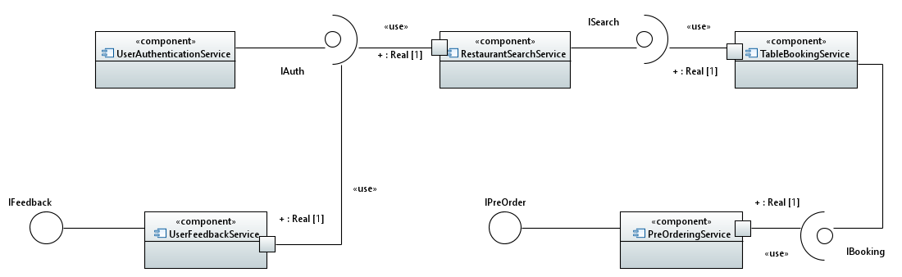

Software Detail Design

Class Diagram for TableBookingService microservice

Github Repository

https://github.com/sree3141/COMP5047-Coursework/tree/main